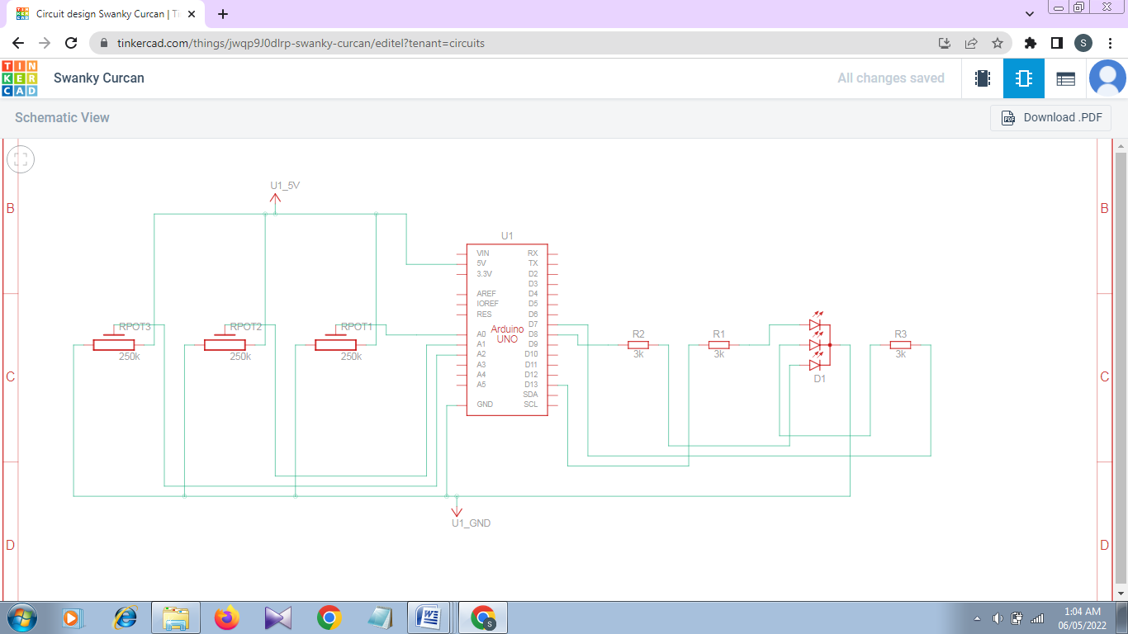**Schematic View:**

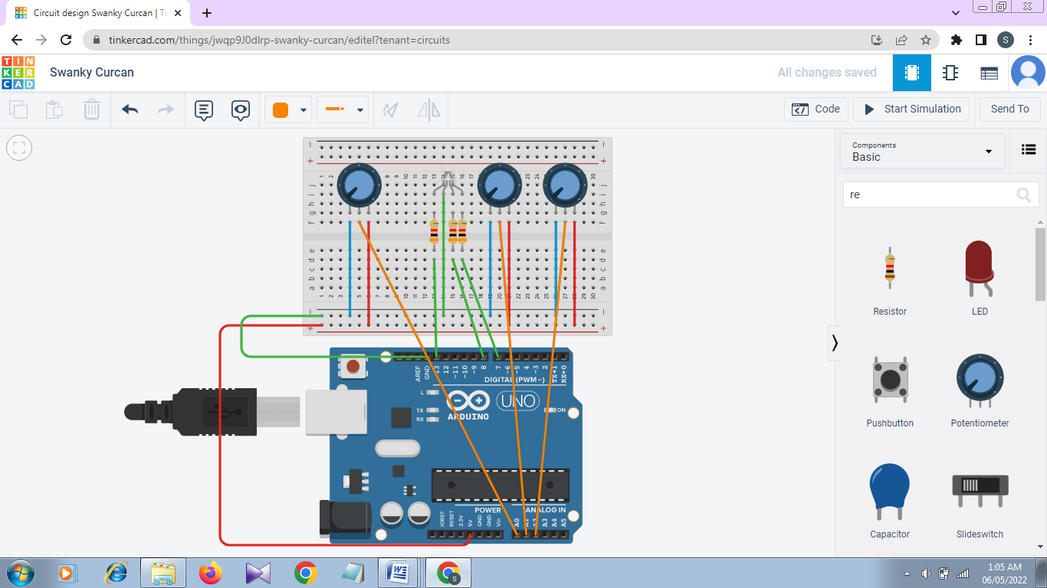**Circuit View:**

**Code:**

int LEDR=13;

int LEDG=7;

int LEDB=8;

int INPUT0=A0;

int INPUT1=A1;

int INPUT2=A2;

int VALUE0;

int VALUE1;

int VALUE2;

void setup()

{

Serial.begin(9600);

pinMode(LEDR,OUTPUT);

pinMode(LEDG,OUTPUT);

pinMode(LEDB,OUTPUT);

}

void loop()

{

VALUE0=analogRead(INPUT0);

VALUE1=analogRead(INPUT1);

VALUE2=analogRead(INPUT2);

analogWrite(LEDR,VALUE0/4);

analogWrite(LEDG,VALUE1/4);

analogWrite(LEDB,VALUE2/4);

}